Wiggle Sort (Pseudocode & Time Complexity Analysis):
- Non-recursive wiggle sort:
It depends on loops not calling the function to itself, the first index is smaller than the 2nd index … (i₁ < i₂ > i₃ < i₄ > i₅) so when the index is even it should be smaller than the value of odd index.

Pseudocode Line | Time Complexity
FUNCTION wiggle_sort(arraySize, array[]) | O(1)
FOR i ← 0 TO arraySize − 2 DO | O(n)
IF i is even THEN | O(1)
IF array[i] > array[i+1] THEN | O(1)
SWAP(array[i], array[i+1]) | O(1)
END IF | O(1)
ELSE (i is odd) | O(1)
IF array[i] < array[i+1] THEN | O(1)
SWAP(array[i], array[i+1]) | O(1)
END IF | O(1)
END IF | O(1)
END FOR | —
END FUNCTION | —
BEGIN MAIN | O(1)
DECLARE array[5] | O(1)
READ 5 integers into array | O(n)
CALL wiggle_sort(5, array) | O(n)
PRINT each element of array | O(n)
END MAIN | O(1)

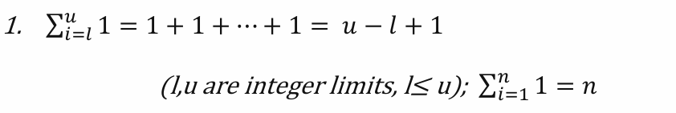
Using this law loop complexity is O(n) as it runs by n-1 times
Since it is the the highest power then total time complexity = O(n)

Space = O (1) only a single temp variable is used.

- Recursive wiggle sort:
It depends on calling the function from the function itself until it stops by condition which is in our case if the {index of array} is bigger than or equal to {array size -1} (base case ), but same as non-recursive 1st index is smaller than the 2nd index … (i₁ < i₂ > i₃ < i₄ > i₅) so when the index is even it should be smaller than the value of odd index. It uses call stack memory and there is risk of stack overflow.

Pseudocode Line | Time Complexity
FUNCTION wiggle_sort_rec(index, arraySize, array[]) | O(1)
IF index ≥ arraySize − 1 THEN | O(1)
RETURN | O(1)
END IF | O(1)
IF index is even THEN | O(1)
IF array[index] > array[index+1] THEN | O(1)
SWAP(array[index], array[index+1]) | O(1)
END IF | O(1)
ELSE (index is odd) | O(1)
IF array[index] < array[index+1] THEN | O(1)
SWAP(array[index], array[index+1]) | O(1)
END IF | O(1)
END IF | O(1)
CALL wiggle_sort_rec(index + 1, arraySize, array) | O(n)
END FUNCTION | —
BEGIN MAIN | O(1)
DECLARE array[5] | O(1)
READ 5 integers into array | O(n)
CALL wiggle_sort_rec(0, 5, array) | O(n)
PRINT each element of array | O(n)
END MAIN | O(1)

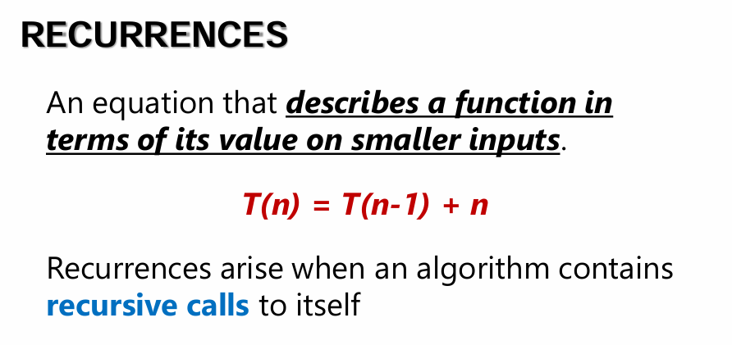
T(n) = T(n−1) + O (1)
T(n) = T(n−2) + O(1) + O(1) = T(n−2) + 2·O(1)
T(n) = T(1) + (n−1) ·O(1)
T(1) = O(1) (base case)
Then T(n) = O(n)

Space = O(n) each of the (n−1) recursive calls occupy a stack frame.
In C this can cause a stack-overflow for very large n.

